Customer Shopping Behavior Analysis
1. Project Overview
This project examines customer shopping patterns using transactional data from 3,900 purchases across multiple product categories. The objective is to identify meaningful insights related to spending behavior, customer segmentation, product choices, and subscription trends in order to support informed business strategies.
2. Dataset Summary
- Total Records: 3,900
- Total Columns: 18
Key Attributes Include:
- Customer demographics: Age, Gender, Location, Subscription Status
- Purchase information: Item Purchased, Category, Purchase Amount, Season, Size, Color
- Behavioral indicators: Discount Applied, Promo Code Used, Previous Purchases, Frequency of Purchases, Review Rating, Shipping Type
Missing Data:
- 37 missing values were identified in the Review Rating column.
3. Exploratory Data Analysis Using Python
The dataset was first processed and prepared using Python for reliable analysis.
- Data Import: The dataset was loaded using the pandas library.
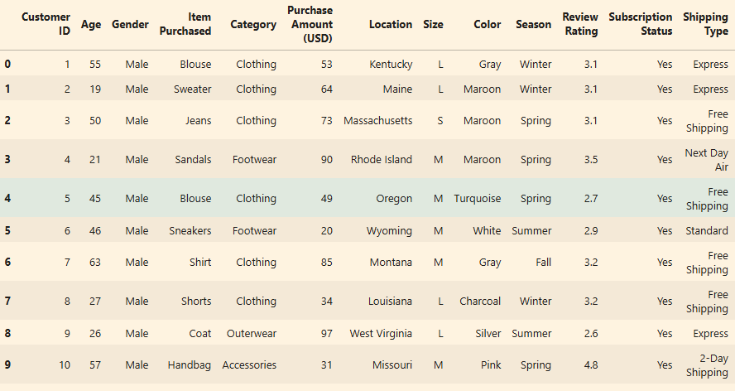

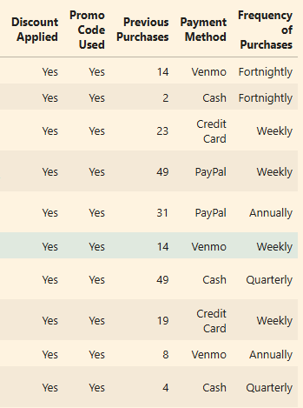
- Initial Inspection: Dataset structure was reviewed using df.info() and descriptive statistics were generated with describe().
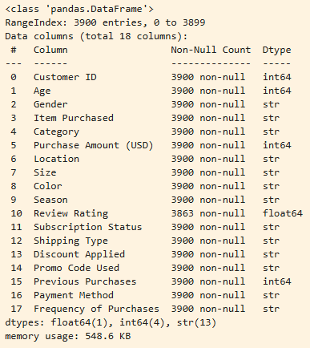
- Handling Missing Values: Null values were examined, and missing entries in the Review Rating column were replaced with the median rating within each product category.
- Column Formatting: Column names were converted to snake_case to maintain readability and consistent documentation standards.
Feature Engineering:
- Generated an age_group variable by grouping customer ages into ranges.
- Created a purchase_frequency_days variable derived from purchase data to better understand buying patterns.
Data Validation:
- Checked whether discount_applied and promo_code_used contained overlapping information. Since they were redundant, the promo_code_used column was removed.
Database Integration:
- The cleaned dataset was then connected to PostgreSQL, and the processed DataFrame was uploaded for further SQL-based analysis.
4. Data Analysis Using SQL (Business Transaction Insights)
Structured analysis was performed in PostgreSQL to address key business questions.
- Revenue by Gender: Compared total revenue generated by male and female customers.
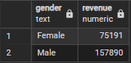
- High-Spending Discount Users: Identified customers who used discounts but still spent above the average purchase value.
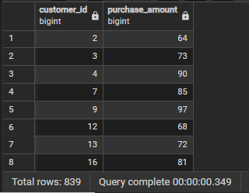
- Top 5 Products by Rating: Determined products with the highest average customer ratings.
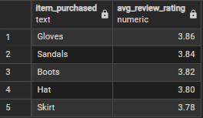
- Shipping Type Comparison: Analyzed differences in average purchase amounts between Standard and Express shipping.
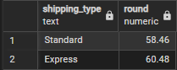
- Subscribers vs Non-Subscribers: Evaluated differences in average spending and total revenue between subscribers and non-subscribers.
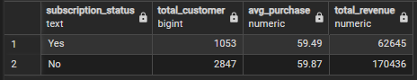
- Discount-Driven Products: Identified five products with the highest percentage of discounted purchases.
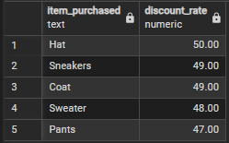
- Customer Segmentation: Categorized customers as New, Returning, or Loyal based on their purchase history.
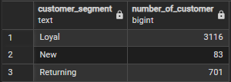
- Top Products per Category: Determined the three most frequently purchased products in each category.
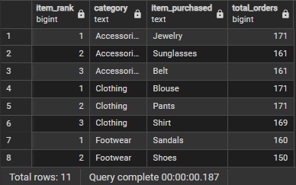
- Repeat Buyers and Subscriptions: Examined whether customers with more than five purchases are more likely to subscribe.
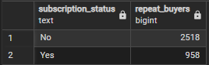
10. Revenue by Age Group: Measured the contribution of each age group to overall revenue.
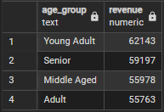
5. Power BI Dashboard
An interactive dashboard was developed in Microsoft Power BI to visually communicate the findings. The dashboard provides a clear view of customer demographics, purchasing trends, and revenue insights to support decision-making.
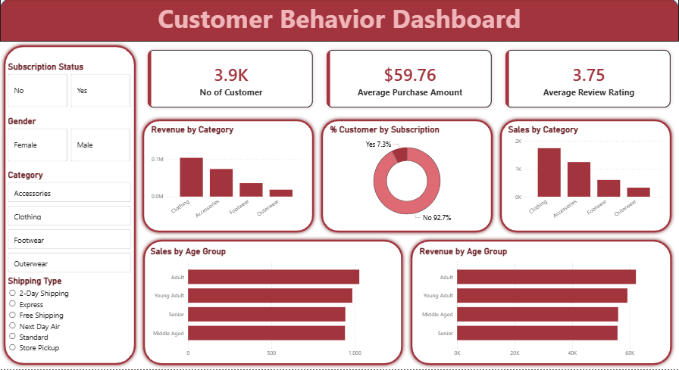
6. Business Recommendations
- Increase Subscription Adoption: Introduce exclusive benefits and incentives for subscribers.
- Strengthen Loyalty Programs: Reward repeat customers to encourage progression into the Loyal segment.
- Evaluate Discount Strategy: Ensure promotional discounts increase sales while maintaining healthy profit margins.
- Product Promotion: Feature highly rated and frequently purchased products in marketing campaigns.
- Targeted Marketing: Focus marketing initiatives on age groups and customer segments contributing the highest revenue, as well as customers opting for express shipping.

